Nexora backend database and maintenance
Document 30 of the Nexora learning guides
Source snapshot 14 October 2026 at 06:41 UTC
Understand the shared API, module boundaries, SQL contexts, migrations, health checks and Git maintenance.

Recognise the screen and its scope
Open /health, /health/ready, /api/v1/platform. CRM routes use port 3017; member routes use 3018; public website routes can use 3019. Brackets name a route parameter, not text to paste into a browser. Choose a real record or site id from the application.
This guide covers Nine modules and shared BuildingBlocks; Nine database contexts; Identity CRM Membership Events Finance Engagement Work and Content schemas; Workflow context and schema; Per-context migration histories; Readiness cancellation logging testing and release runbook; Local Git and documentation updates.
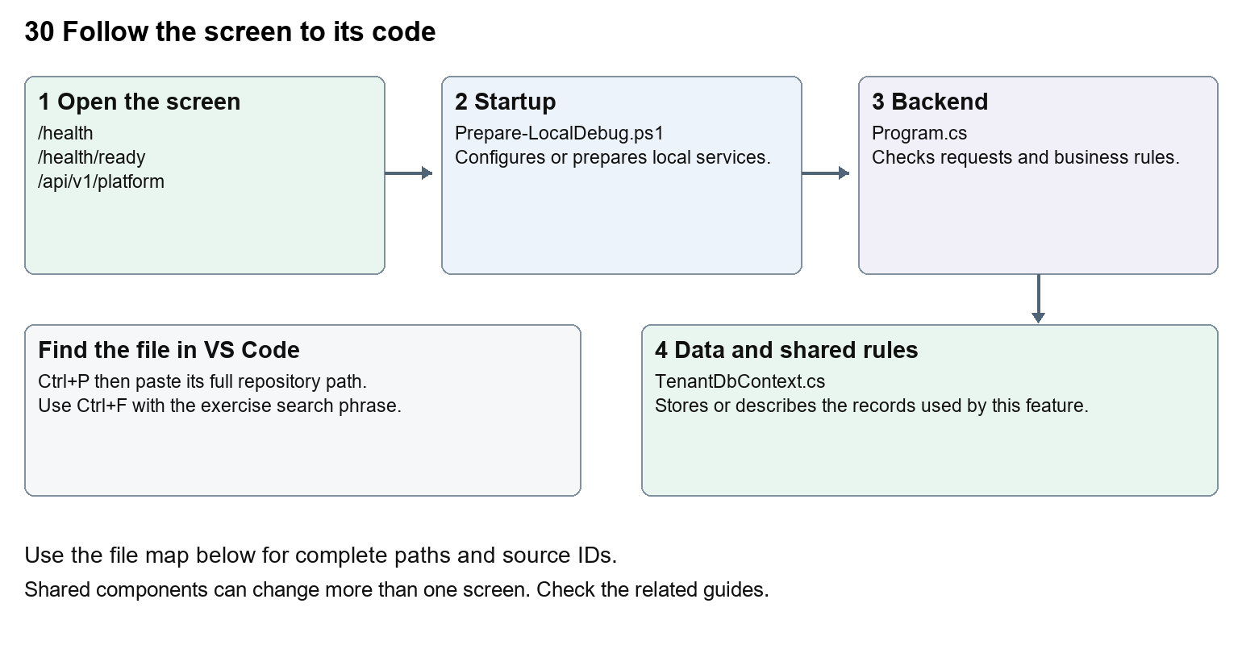
The diagram shows the file roles. The full paths below are what you paste into Ctrl+P.

Find the files in VS Code
Role | File and source ID | What it does
Startup | S0678 Prepare-LocalDebug.ps1 | Local service setup
Server | S0576 Program.cs | Endpoints or server rules
Data | S0196 TenantDbContext.cs | Data shape or persistence structure

Startup S0678
scripts/Prepare-LocalDebug.ps1
Server S0576
backend/src/Nexora.Api/Program.cs
Data S0196
backend/src/BuildingBlocks/Nexora.BuildingBlocks/Persistence/TenantDbContext.cs
The complete HTML manual opens these source IDs inside its Source library. The Word manual shows short labelled extracts so you can learn the flow before reading large files. Each individual Markdown guide includes its complete primary files after the walkthrough.

Follow the request and the records
1. Program registers module services and their database contexts.
2. Middleware applies errors, CORS, limits, authentication and authorisation.
3. Each module maps endpoints and tenant-scoped persistence.
4. Development startup and preparation manage the configured local database.
5. Operational checks report health and readiness; reviewed release steps govern deployment.

Read the code with an explanation
A DbContext is a C# gateway to a group of tables. Different modules can use the same SQL database with separate schemas and migration histories. Identity plus eight business and Workflow contexts totals nine contexts in current source; read the generated context inventory for the exact names. Never apply one context's migration to another or drop a database to repair a missing table.
Source reference S0678 scripts/Prepare-LocalDebug.ps1
Selected opening lines with their original numbers. The complete file is in the HTML source library.
0001 param([switch]$WaitForApi)
0002 $ErrorActionPreference = 'Stop'
0003 $root = Split-Path $PSScriptRoot -Parent
0004 function Wait-NexoraApi {
0005 param($StartedProcess)
0006 $deadline = (Get-Date).AddSeconds(180)

The import lines lead to shared components and helpers. Start at the exported component or route function; follow the request helper to the server rather than assuming the whole feature lives in this file.
Source reference S0576 backend/src/Nexora.Api/Program.cs
Extract from source line 83. A fragment from a long line is shown without the rest of that line.
0083 app.MapGet("/api/v1/platform", () =>

On the server, look for MapGet to load records, MapPost to create or perform an action, MapPut or MapPatch to change data, and RequireAuthorization for permissions. Some shared methods register endpoints indirectly. Find SaveChangesAsync to see the database write. A request method alone does not tell you every side effect.
Source reference S0196 backend/src/BuildingBlocks/Nexora.BuildingBlocks/Persistence/TenantDbContext.cs
Selected opening lines with their original numbers. The complete file is in the HTML source library.
0001 using Microsoft.EntityFrameworkCore;
0002 using Microsoft.EntityFrameworkCore.ChangeTracking;
0003 using Microsoft.EntityFrameworkCore.Metadata.Builders;
0004 using Microsoft.EntityFrameworkCore.Storage.ValueConversion;
0005 using Nexora.BuildingBlocks.Domain;
0006 using Nexora.BuildingBlocks.Security;

Follow model fields to their request names and database mapping. An id points to a particular record. A tenant id limits the organisation. A version or concurrency stamp protects newer edits. Some model files describe contracts rather than tables; check the owning DbContext before assuming storage.

Make or trace your first change
1. Press Ctrl+P and open backend/src/Nexora.Api/Program.cs.
2. Press Ctrl+F and search for AddNexora. In this snapshot it appears at line 28.
3. Read-only exercise: list the registered modules, then find each DbContext. Compare the generated database inventory with the health/readiness checks. Follow the Git practice instructions using only your own documentation or text change.
4. Record the file, request path and server handler you found. This exercise is read-only; no stored records need to change.
Extract from source line 28. A fragment from a long line is shown without the rest of that line.
0028 builder.Services.AddNexoraIdentity(builder.Configuration, builder.Environment.IsDevelopment());

These exercises have not been applied to the application. Their search phrases are verified against the captured source. Line numbers can move; the phrase and file path are your main navigation aids.

Check a change and diagnose problems
Confirm the original screen still loads, the changed words appear in the intended place, and another screen using the same component still behaves correctly. If an action fails, inspect the browser Network response, the relevant helper and server validation message. Use the common error table at the beginning of the manual. Reload on a version conflict instead of removing the version check.
A syntax error after a text edit usually means a quote, brace or closing tag changed. Compare your diff with the original. An unchanged browser result can mean the wrong port, a saved published configuration overriding a default, or a running API that has not reloaded.

Understand the current limits
A successful build, a health response and production approval are different results. This manual records source coverage and documentation checks; it does not claim a full platform regression, live provider delivery, backups or production acceptance.

Continue learning
Related guides 02 Nexora platform setup and VS Code, 18 Nexora imports exports and migration, 20 Nexora administration and access, 22 Nexora workflow designer and runtime, 29 Nexora documents evidence and file safety.

